* PEST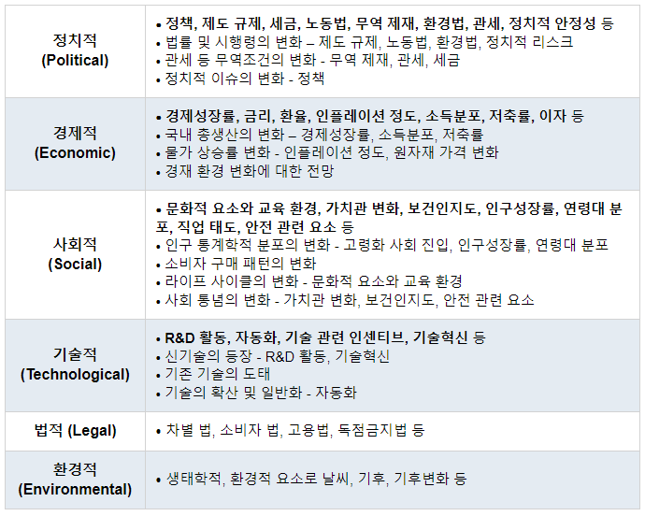
* STEEP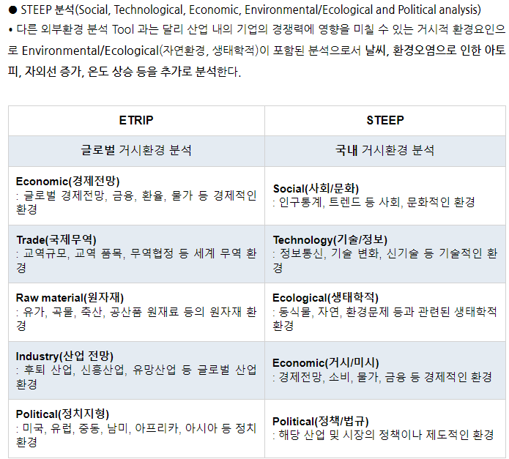

http://www.m-economynews.com/mobile/article.html?no=32733